How do I get tickets to a NNDABC Event

Click/touch Events from the top navigation bar.

Click on Events
Browse through all available events/trips and Click on “Select” the trip that you desire.

Click on “Register Now”
Choose the number of tickets required.
Enter the requested info. Click “Checkout”
Fill in the Details. Name and email is mandatory.

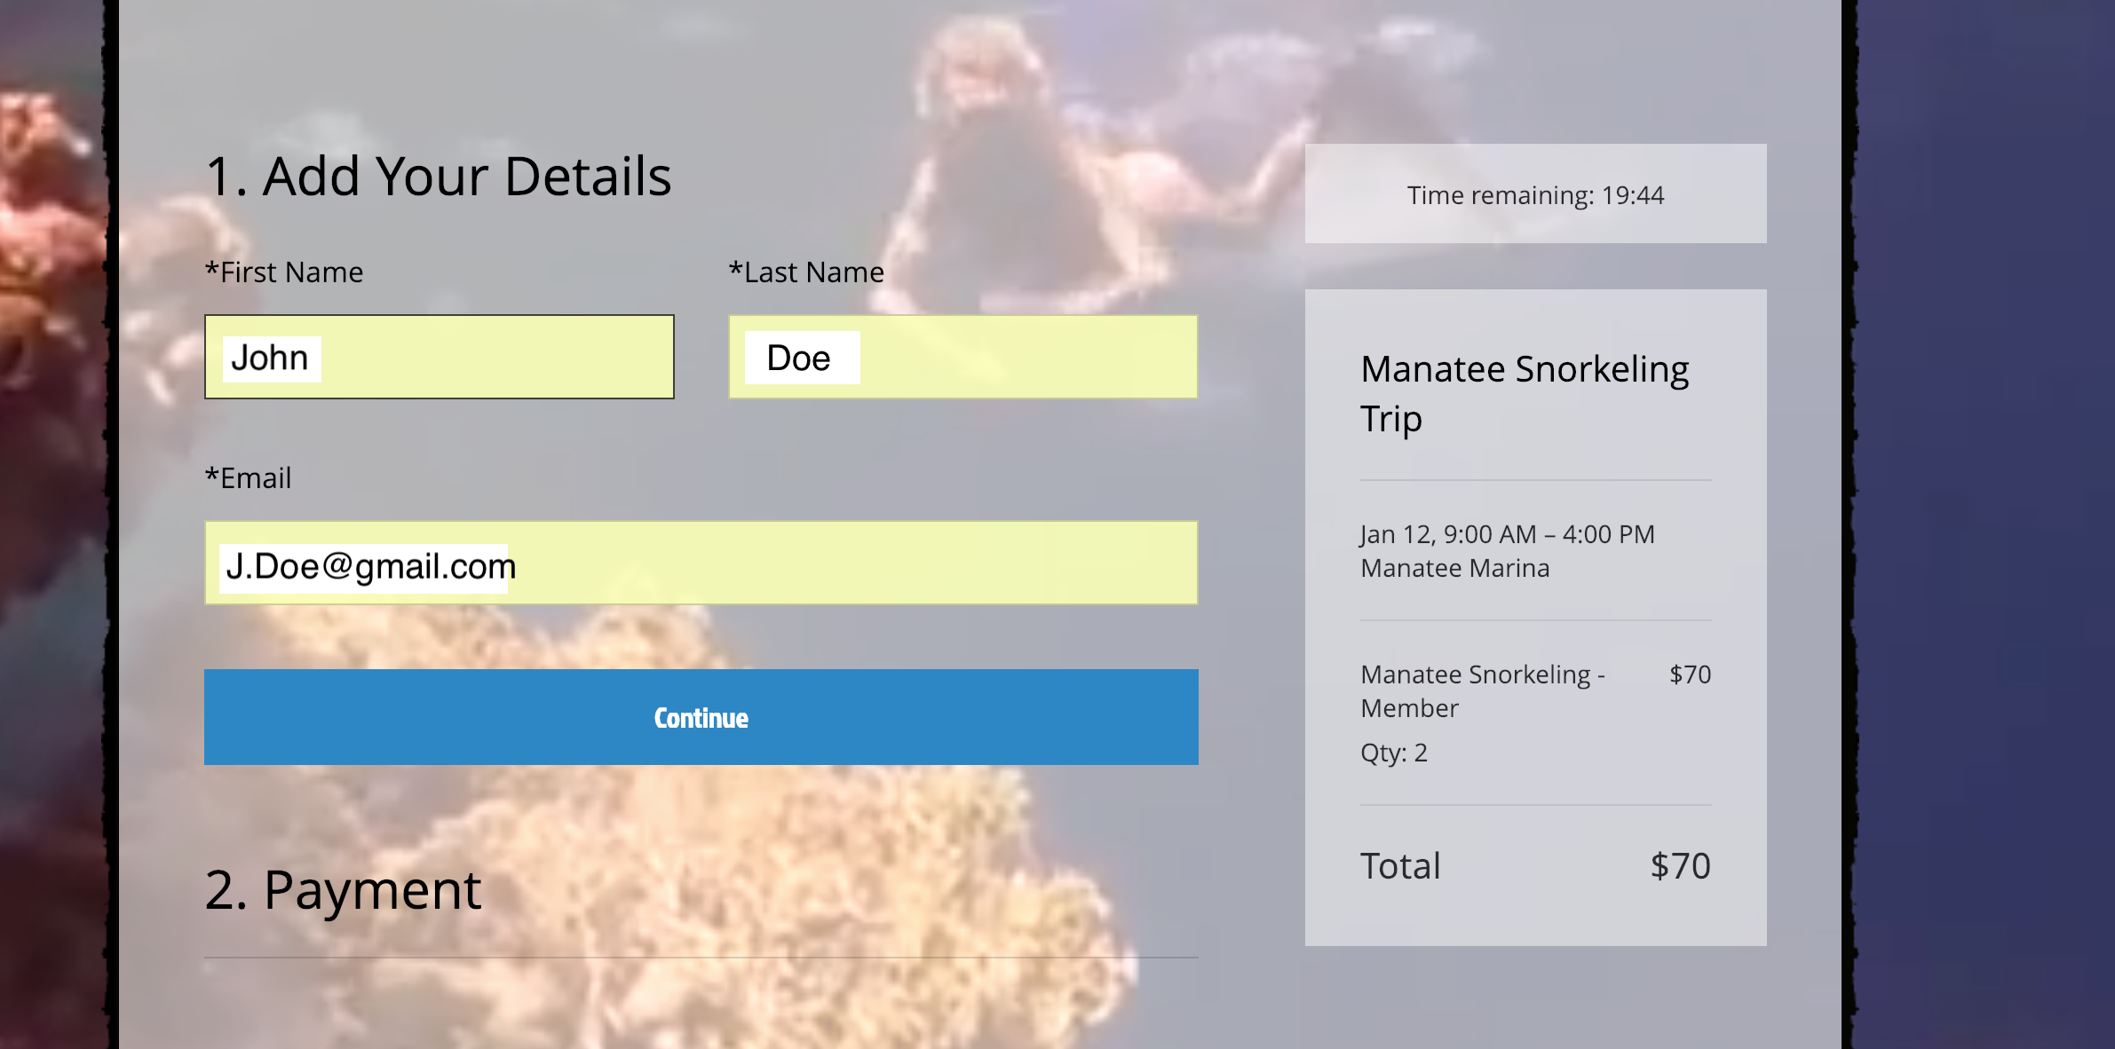

Click on “Continue”
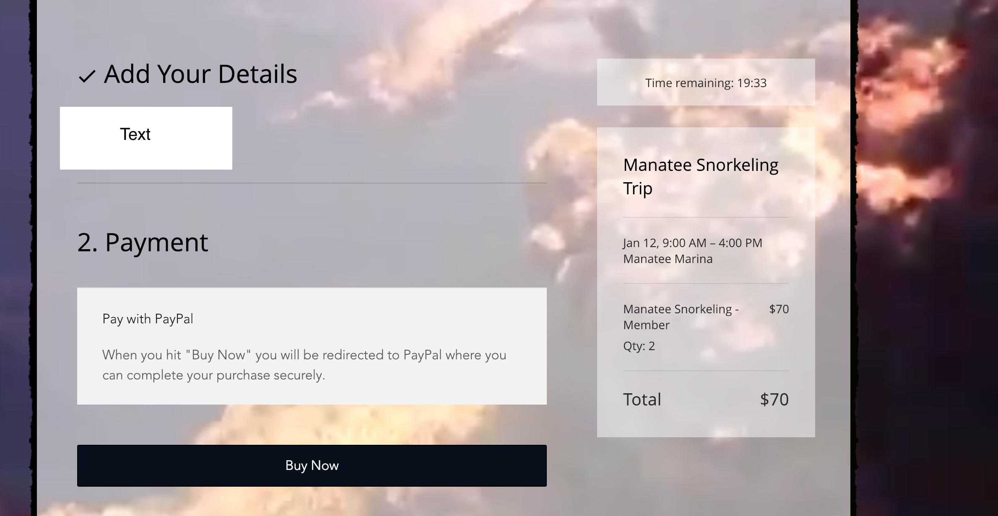
Click on “Buy Now”

Choose what method of payment
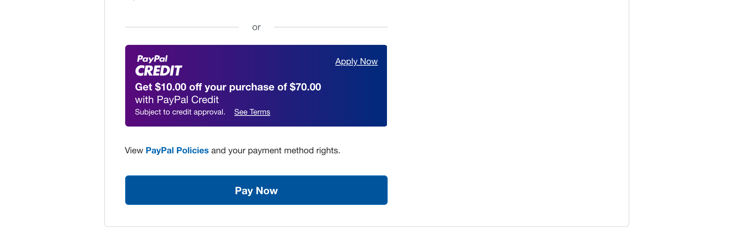

Click “Pay Now”
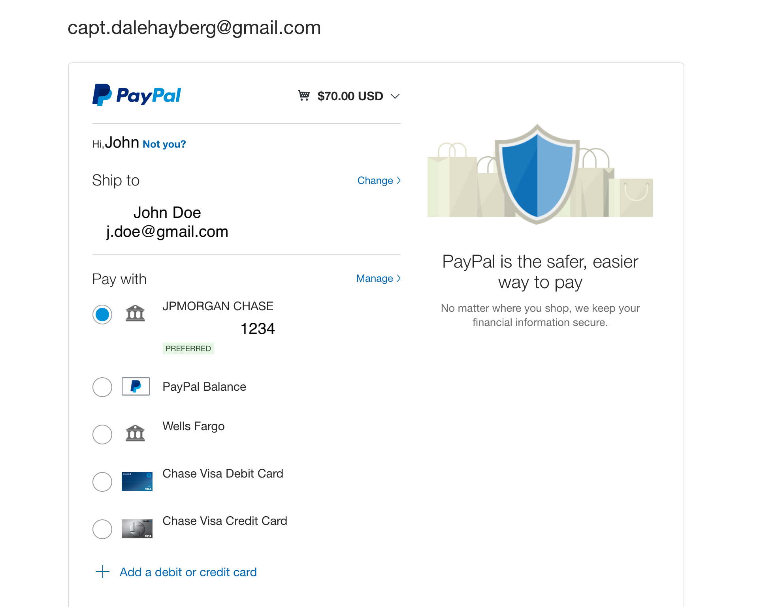
That’s it.
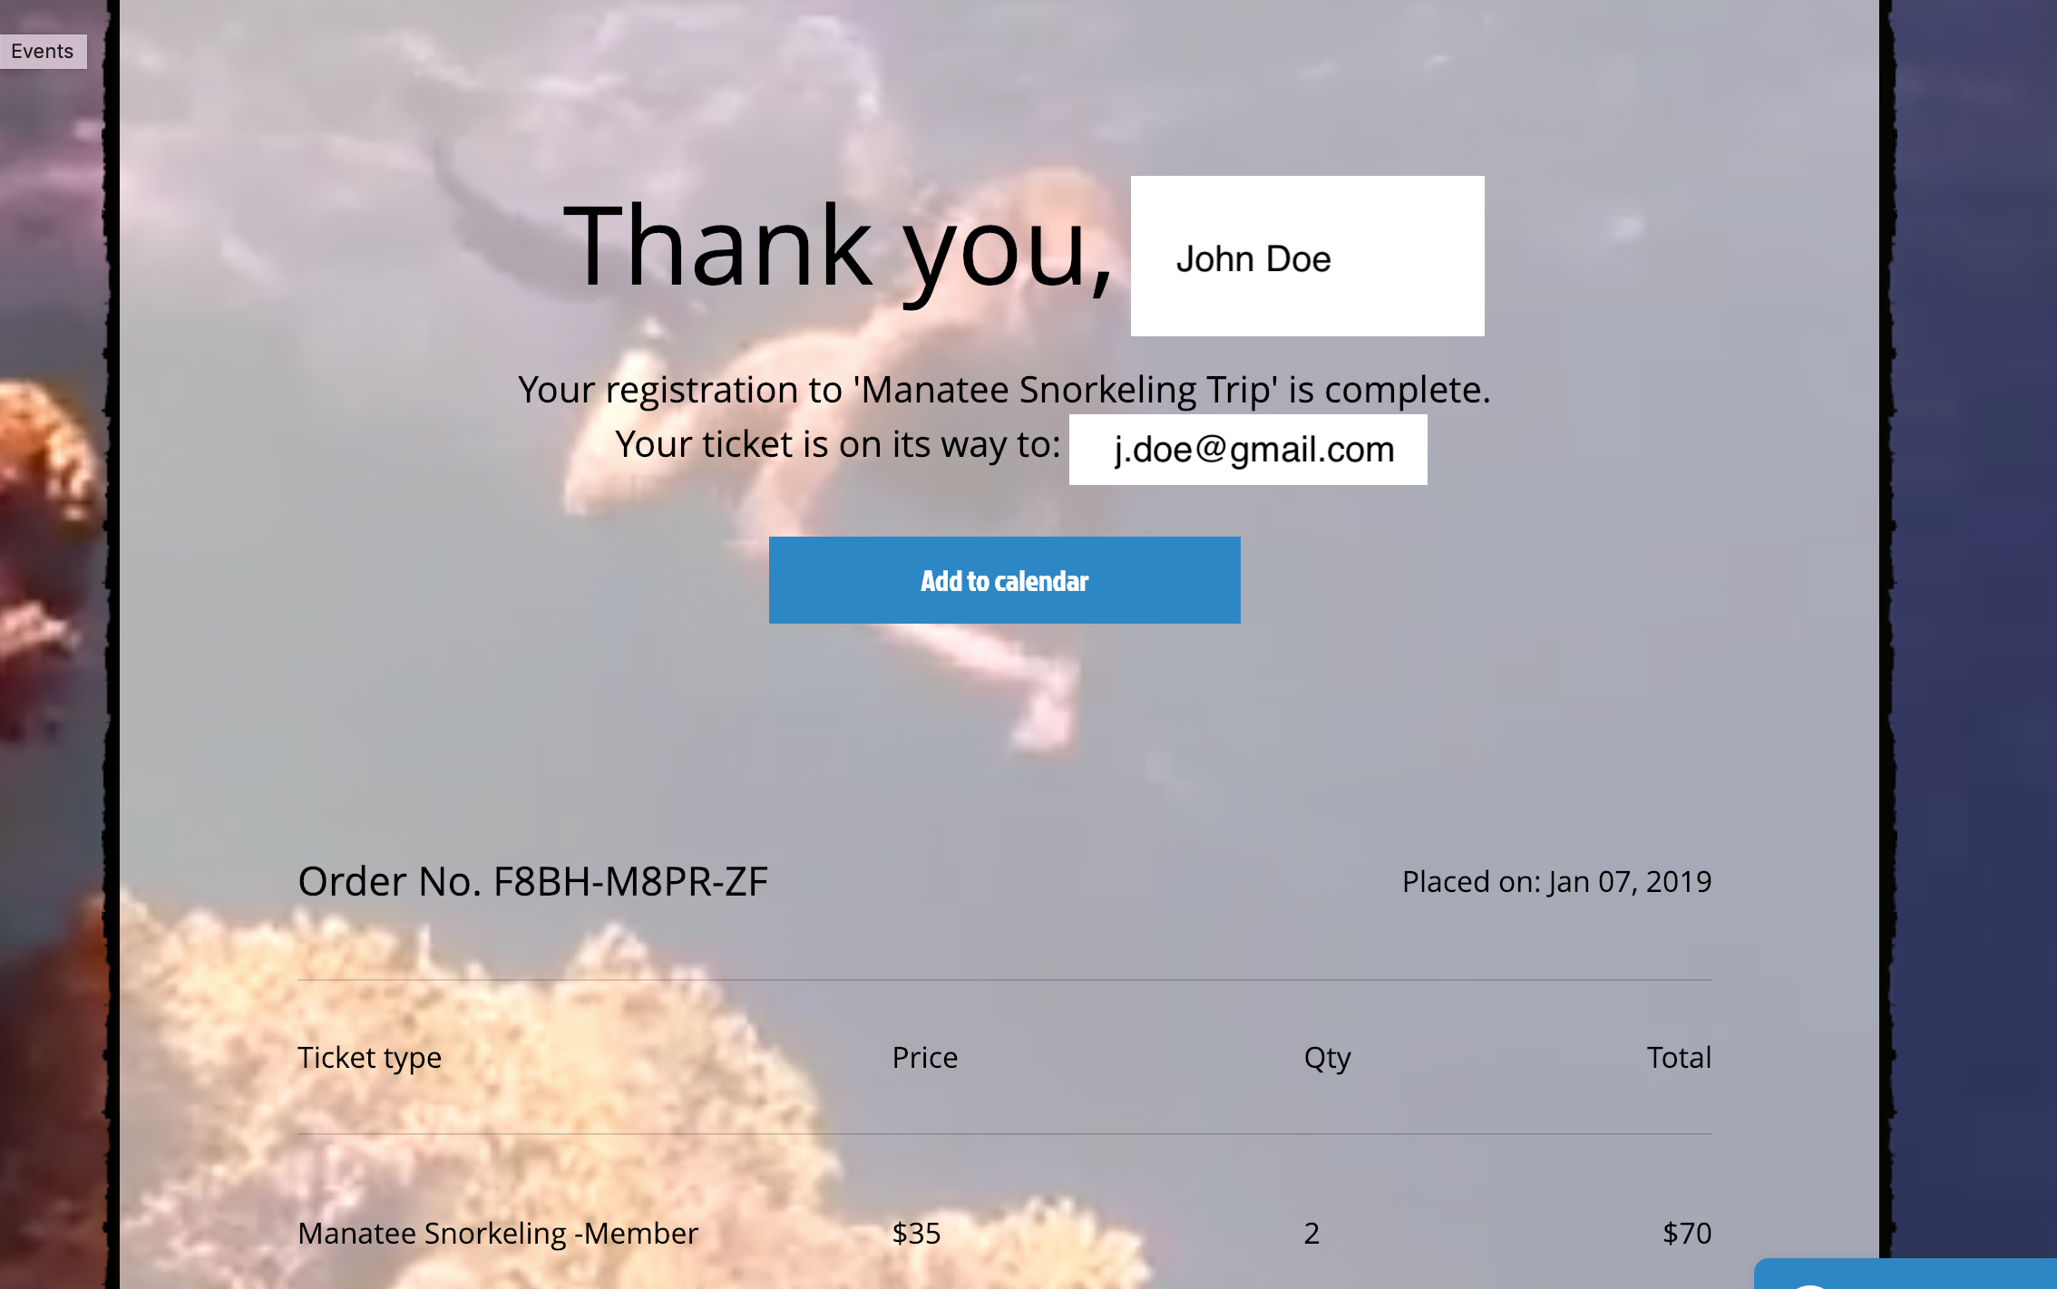
Click on “Add to Calendar”
Check your email for your tickets & calendar information.

